Address Book
System Design Document
Version 1.0

Document Revisions
Date | Version | Detailed Description | Author
19/05/2013 | 0.1 | Initial Design | Vijitha Epa

Contents
Introduction 2
Problem Background 2
System Overview 2
Application Tools and Technologies 2
Development Tools 2

Architecture Views 3
System Use Case View 3
High level Application Design 3
Application Structure 3
Runtime Integration Views 4
Class Diagram 6

Assumptions 7

Introduction

Problem Background

This document details the design and architectural aspects of the Address Book Application implemented as a part of coding assignment at Reece.

System Overview

The Address Book design is influenced by the given requirement to support the following functionalities:

- Implement an Address Book that holds the name and phone number of friends;
  - To be able to print the list of friends and their corresponding phone numbers sorted by their name
  - Given another address book that may or may not contain the same friends, print out the list of friends that are unique in either address book.

Application Tools and Technologies

Tool/Technology | Version | Used in
Java | 1.7 | Business Layer and GUI implementation
Junit | 4.11 | Test suite implementation
Maven | 3.0.5 | Build tool

Development Tools

Tool | Version | Used in
Eclipse Java IDE (Juno) | R2 | Application development
Net beans | 7.2 | User Interface development

Architecture Views

This section intends to show the different architecture views to get an understanding of the application.

System Use Case View
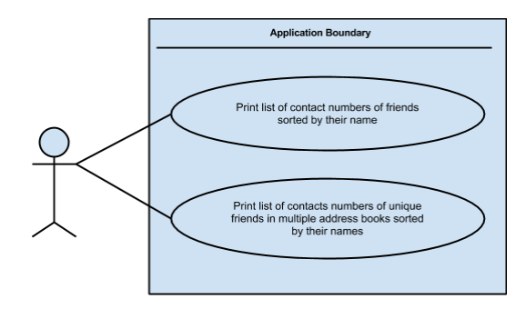

High level Application Design

Application Structure

Based on the initial reading of the use cases application is build up using Object Oriented design patterns. (Builder pattern, Singleton, Delegate etc...) Following diagram depicts the high level architecture of the application.

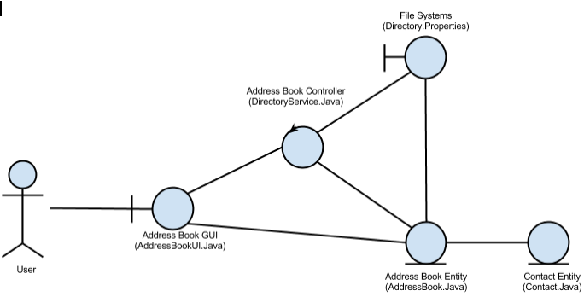

- Address Book Entity - A single entity object representing the current address book that the program is working with.

- Contact Entity - An arbitrary number of entity objects, each representing one of the friends that is in the current address book.

- Address Book GUI - A boundary object representing the interface between the address book system and the end user.

- File Systems/ Data Storage -A boundary object representing the interface between the address book system and the file system or data storage on disk. For this application data will be stored in “Directory.Pripperties” File.

- Address Book Controller - A controller class that carries out the use cases in response to user gestures on the GUI. Single controller is used with few Utility classes in this application since scope is small.

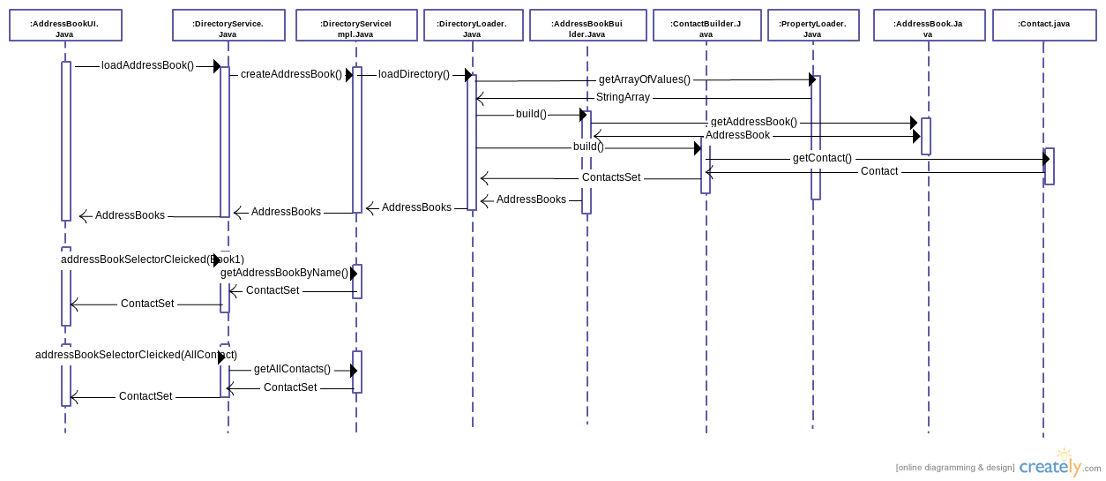

Runtime Integration Views

Class Diagram

Below diagram depicts the class diagram for the Address Book Application. To prevent the diagram from becoming overly large, only the name of each class is shown.

The diagram includes the classes discovered during the requirement analysis, and then some of the additional classes discovered during design.

AddressBook
Contact
DirectoryService
DirectoryServiceImpl
AddressBookUI
AddressBookBuilder
ContactBuilder
EntityBuilder
PropertyLoader
DirectoryLoader
*
1

Assumptions and limitations

Assumptions
- GUI is supported only for the requirement prototyping. Advance GUI’s are not provided.
- Deployment guide and advance User Guide will not be provided. Read me file is provided with the details of how to execute the Application
- Data will be stored in basic file system. Will not be integrated with a Database
- /BasicAddressBook/src/test/resources/Directory.properties file used as it is for Test Cases. But when Application runs, properties can be changed as needed.

Limitations
- Exception handling not implemented for all scenarios.
- Data base implementation is not implemented.

